Output Test Implementation Plan (Different Timeline)

- 1 - 3 Months

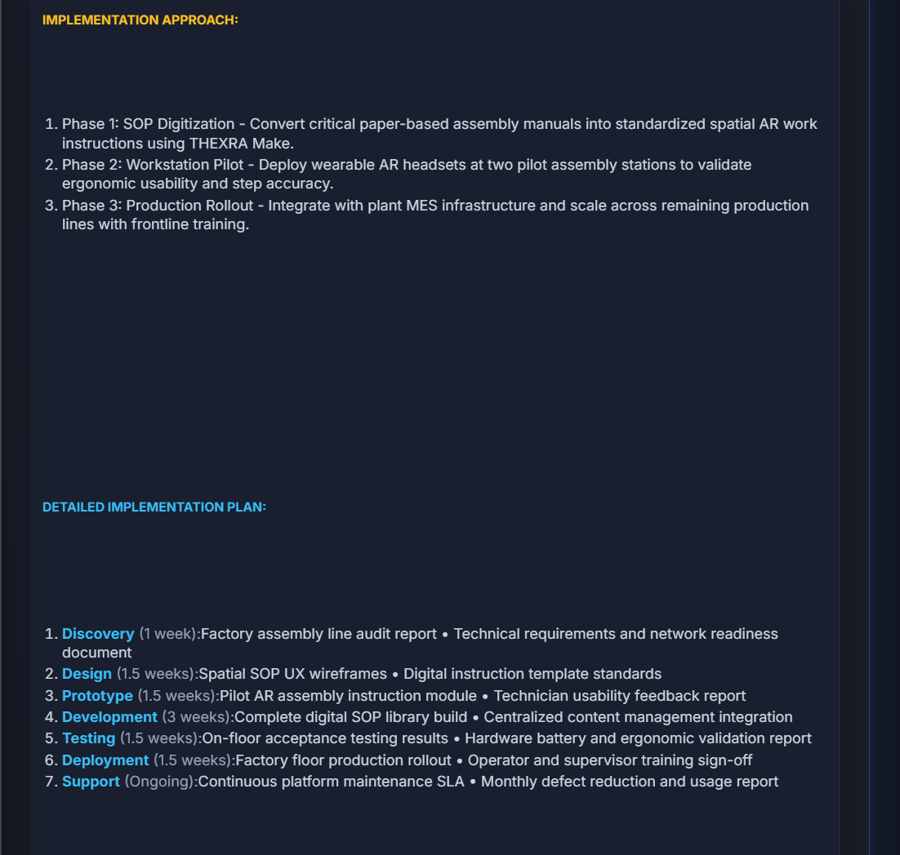 | 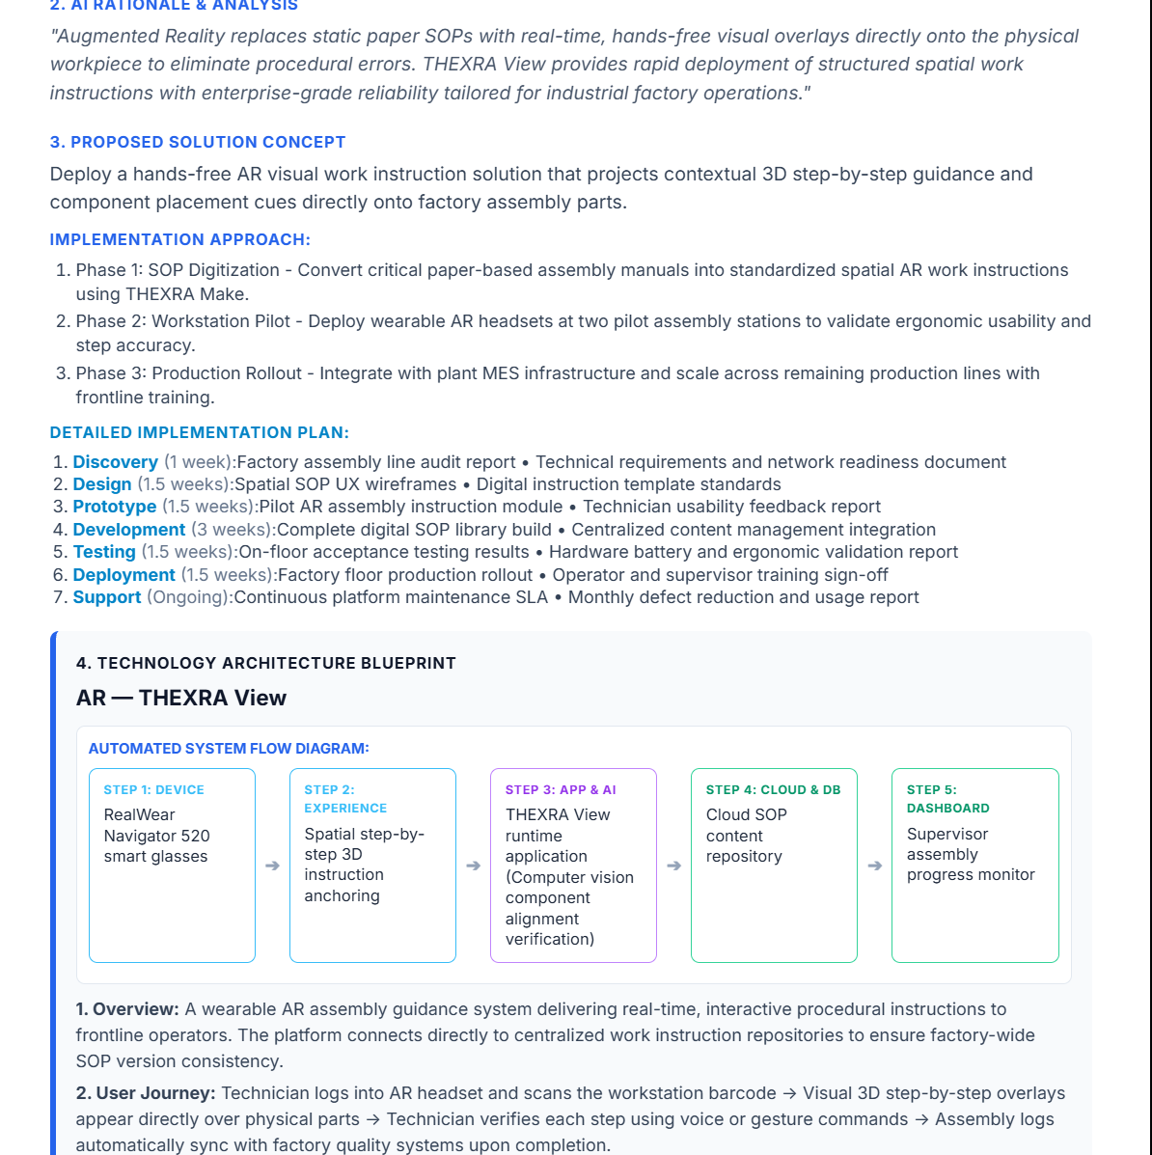

Company Name: Apex Components
Industry Vertical: Manufacturing
Primary Operating Location / HQ: Penang, Malaysia
Target User Count: 1-50
Core Problem: High assembly error rates from reading static paper SOP manuals on the factory floor.
Target End User: Assembly line technicians
Current Operational Process: Manual lookup of paper binders at workbench stations during assembly.
Desired Business Outcome / KPIs: Reduce assembly errors by 35% and speed up operator onboarding.
Estimated Budget Range: $10k-50k
Delivery Timeline: 1 - 3 Months
Existing Systems: CAD / BIM Models Available
Special Technical Requirements: Hands-free AR smart glass overlay with offline caching support.

- 3 - 6 Months

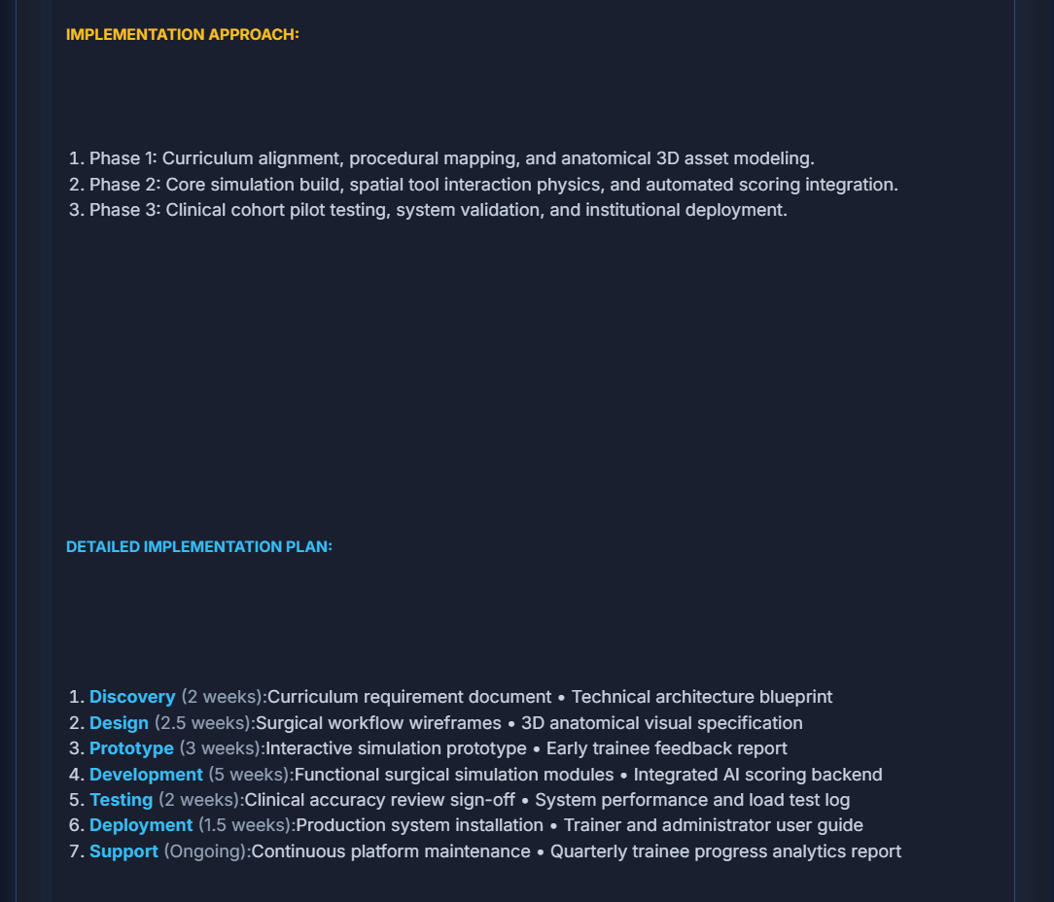 | 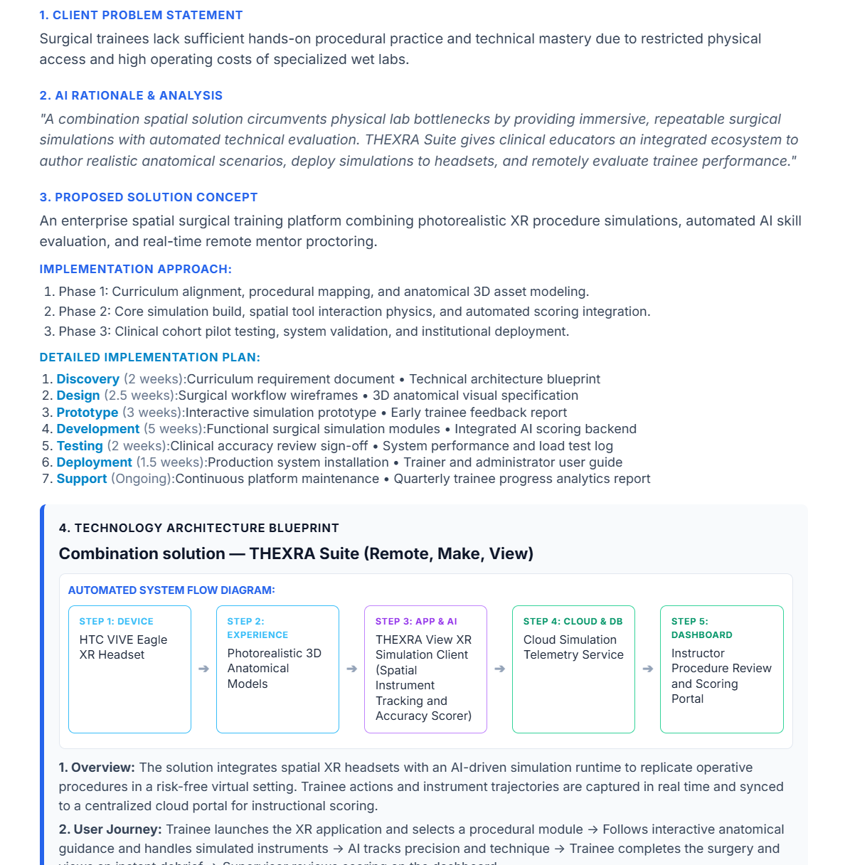

Company Name: MedicSim Institute
Industry Vertical: Healthcare
Primary Operating Location / HQ: Singapore
Target User Count: 51-250
Core Problem: Trainees lack hands-on surgical practice due to limited access to physical labs.
Target End User: Surgical residents and instructors
Current Operational Process: Observing live surgeries and practicing on low-fidelity rubber models.
Desired Business Outcome / KPIs: Boost exam pass rates by 40% and ensure 100% procedure accuracy.
Estimated Budget Range: $50k-100k
Delivery Timeline: 3 - 6 Months
Existing Systems: LMS enterprise, Existing VR/AR Headsets
Special Technical Requirements: Haptic tracking and SCORM LMS integration for score logging.

- 6 - 12 Months

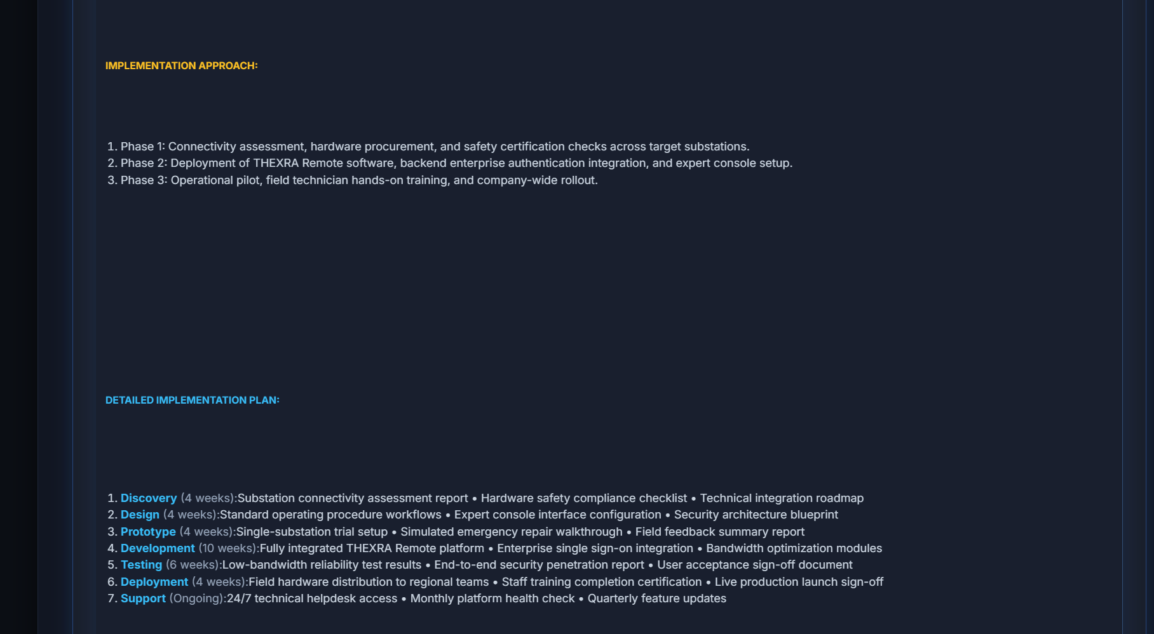 | 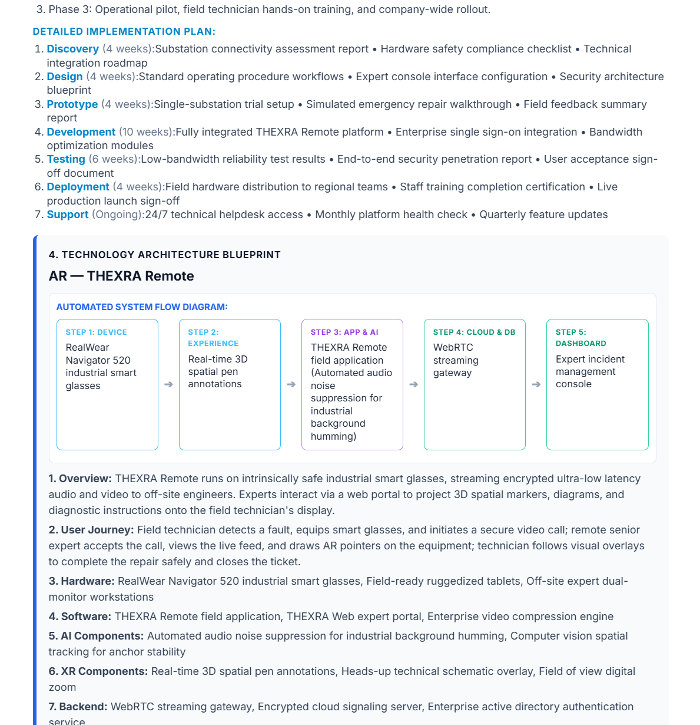

Company Name: Horizon Grid
Industry Vertical: Energy
Primary Operating Location / HQ: Houston, USA
Target User Count: 251-1000+
Core Problem: Extended substation downtime while waiting for senior experts to travel on-site.
Target End User: Field engineers and remote specialists
Current Operational Process: Phone calls and emailing static photos to HQ for remote diagnosis.
Desired Business Outcome / KPIs: Lower MTTR by 45% and save $250k in annual specialist travel costs.
Estimated Budget Range: $100,000+
Delivery Timeline: 6 - 12 Months
Existing Systems: CAD / BIM Models Available, IoT Sensors / Live Telemetry
Special Technical Requirements: Real-time IoT Digital Twin overlay and low-bandwidth WebRTC video streaming.

